Comparing PRM, DIA, and DDA in Skyline
In this tutorial, you will perform a targeted analysis with Skyline with PRM, DIA and DDA measurement data.
The four samples used for this tutorial were generated by mixing HeLa protein digest with PROCAL peptide standard at defined concentrations. Each sample was measured with three technical replicate injections in PRM, DIA and DDA mode on a Quadrupole-Orbitrap-Iontrap (Tribrid) mass spectrometer (Eclipse, Thermo).
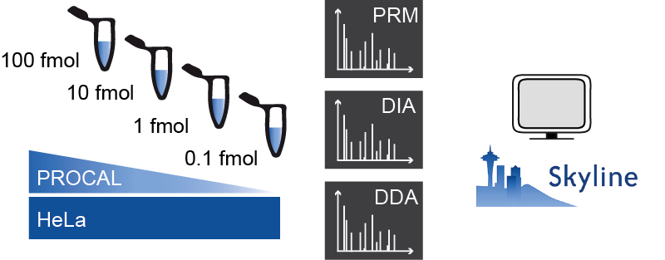
Credits: The samples for this tutorial were measured by the BayBioMS@MRI at TU Munich. The tutorial was written by Julia Mergner and Christina Ludwig.

Getting Started
To start this tutorial, download the following ZIP file:
https://skyline.ms/tutorials/AcquisitionComparisonMzml.zip
Extract the files in it to a folder on your computer, like:
C:\Users\brendanx\Documents
This will create a new folder:
C:\Users\brendanx\Documents\AcquisitionComparisonMzml
If you have been using Skyline prior to starting this tutorial, it is a good idea to revert Skyline to its default settings. To do so:
- Start Skyline.
- On the Start Page, click Blank Document which looks like this:
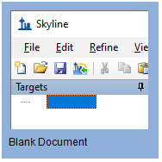
- On the Settings menu, click Default.
- Click No on the form asking if you want to save the current settings.
The document settings in this instance of Skyline have now been reset to the default.
Since this tutorial covers a proteomics topic, you can choose the proteomics interface by doing the following:
- Click the user interface control in the upper right-hand corner of the Skyline window, and click Proteomics interface which looks like this:
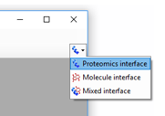
Skyline is operating in proteomics mode which is displayed by the protein icon in the upper right-hand corner of the Skyline window.

Skyline – Loading Libraries

Loading an experimental spectral library file
To start this tutorial, you will first load a previously generated experimental spectral library called PROCAL.blib. This library file contains experimental spectra for all the 41 PROCAL peptides (proteome tools project, Zolg et al., 2017), which are the target peptides of this tutorial. The PROCAL.blib file was generated with Skyline by loading a DDA measurement file of the PROCAL peptides together with the MaxQuant search result file (msms.txt).
To load this experimental spectra library file:
- On the Settings menu, click Peptide Settings.
- Click the Library tab.
- Click the Edit list button.
- In the Edit Libraries window, click the Add button.
- In the Name field, enter "PROCAL".
- Click the Browse button and navigate to the Tutorial\02_PRM subfolder.
- Open the “PROCAL.blib” file.
- Click Ok in the Edit Library and Edit Libraries window.
Skyline has now added “PROCAL” to the Libraries list in the Library tab of the Peptide Settings window.
- Check the box for “PROCAL-Library” to tell Skyline to use this library in picking peptides and transitions.
The Peptide Settings - Library tab should now look like this:
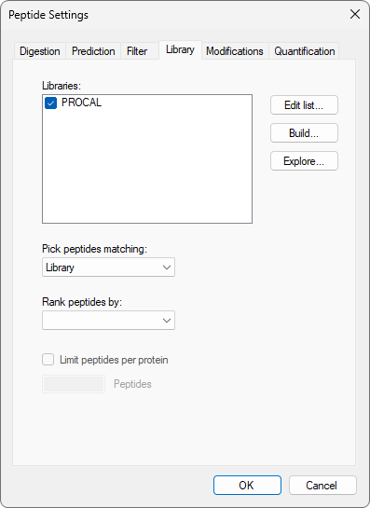
- Click the OK button.
You can explore the loaded PROCAL library:
- On the View menu, choose Libraries, and click Library Explorer.
A Spectral Library Explorer window will open, which will show you all peptides entailed in the loaded library file (for the PROCAL library it is 44 peptides in total), their corresponding spectra as well as raw file and retention time information:
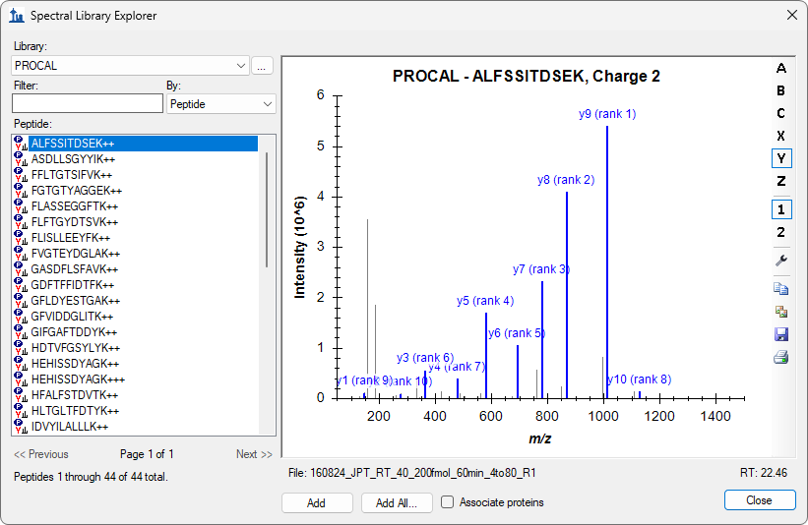
- Click the Close button to close the Spectral Library Explorer when you are done.

Inserting FASTA sequences
To specify your proteins of interest you can import a FASTA file containing exclusively your target proteins via the Import function.
- On the File menu, choose Import and click FASTA.
- Navigate to the 1_PRM subfolder and select the "PROCAL.fasta" file.
- Click the Open button.
The Skyline main window should now look like this:
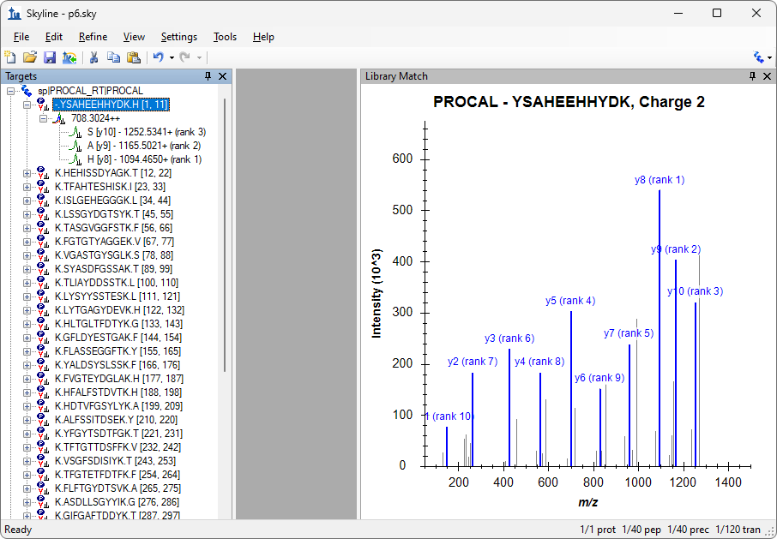
- In case no Library Match window with spectrum information is visible, on the View menu, choose Libraries, and click Library Match (Alt-1).
- Right-click the Library Match window, choose Ion Types, and make sure that the ion types Y and B selected.
Skyline now highlights the y-ions in blue and the b-ions in purple in the spectrum graph.
By default, Skyline chooses the 3 most intense singly-charged product y-ions as the transitions it will target for doubly charged precursors. This selection can be seen when opening a peptide in the Targets window by clicking on the box with "+" in front it:
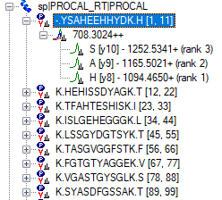
To change the product ion selection setting from the default values, perform the following steps:
- On the Settings menu, click Transition Settings.
- Click the Filter tab.
- In the Precursor charges and Ion charges fields confirm the values are “2” and “1”, respectively.
- In the Ion types field, change from “y” to “p,y,b” (precursor, y-ions, b-ions).
- In the Product ion selection field change From to “ion 2” and To to “last ion”.
- Uncheck “N-terminal to Proline”.
The Transition Settings – Filter tab should look like this:
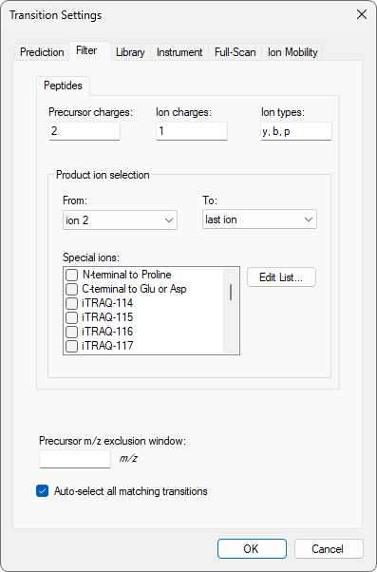
- Click the Library tab.
- Check that the Ion match tolerance field is set to the default “0.5”.
- In the Pick field, enter “6” for product ions and minimum product ions.
The Transition Settings - Library tab should look like this:
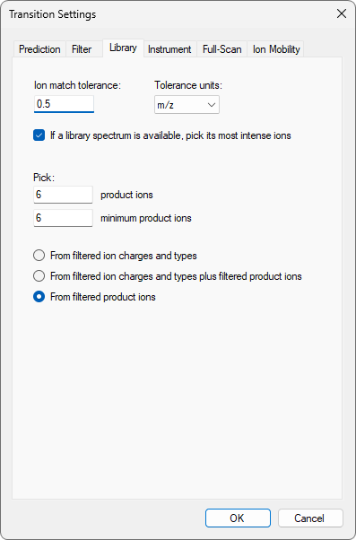
- Click the Instrument tab.
- Change the Min m/z field to “350”.
The Transition Settings - Instrument tab should look like this:
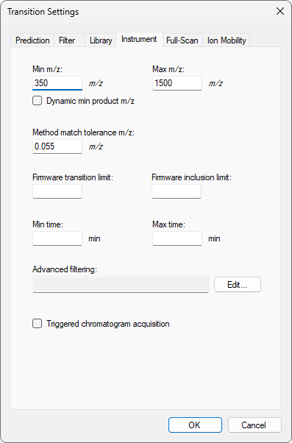
- Select the Full-Scan tab.
- Change the Isotope peaks included field to “Count”.
- Change the Precursor mass analyzer field to “Centroided”.
- Check the Mass Accuracy field is by default set to “10” ppm.
The Transition Settings - Full-Scan tab should look like this:
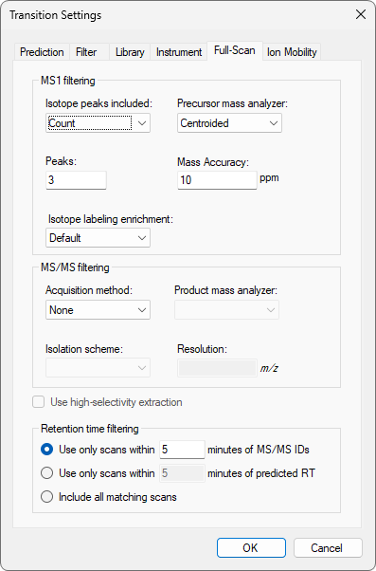
- Click the OK button.
The Skyline Targets tree should now look like this:
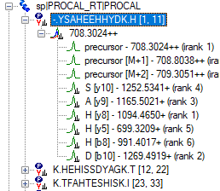
Skyline has picked the top 6 ranked product ions for each peptide precursor, including b-ions, based on the spectral library file (“PROCAL.blib”) you provided in the first step of this tutorial, as well as 3 precursor isotopes (irank 1,2,3) for each peptide.

Creating a predicted spectral library using Koina
Skyline is not limited to using just a single spectral library. You can for example use the Koina prediction framework to predict spectra for unmodified peptides directly in Skyline.
- On the Settings menu, click Peptide Settings.
- Click the Library tab.
- Click the Build button.
- In the Name field of the Build Library window, enter “PROCAL-Koina”.
- Click the Browse button.
- Navigate to the “1_PRM” subfolder.
- Click the Save button.
- In the Data source field select Koina.
- In the Pop-up window click Yes to confirm that you want to change the Koina settings now. If there is no Pop-up window click on Koina - Info/Settings.
- In the Intensity model field of the Options form select “Prosit_2020_intensity_HCD”.
- In the NCE field, select “31”.
The Options form should look like this:
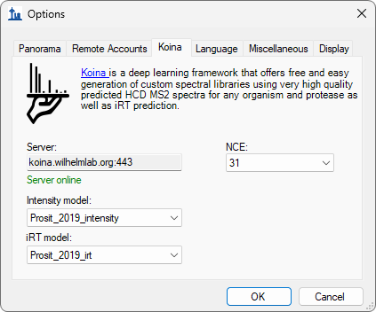
In case you cannot get an online connection to the Koina prediction server please add the PROCAL_Koina.blib spectral library file from the 4_backup subfolder. Just follow the same steps as for the PROCAL library. You can still perform the Mirror spectrum comparison of both libraries. Only the online Koina prediction used later in this tutorial will not work.
- Click the OK button.
- In the NCE field of the Build Library form Select “31”.
The Build Library form should look like this:
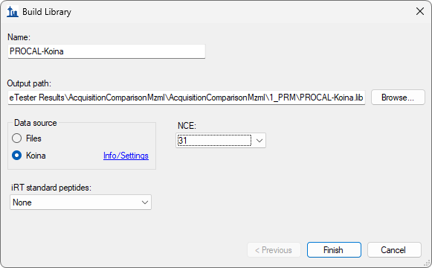
- Click the Finish button.
- Make sure both Libraries are ticked in the Peptide Settings - Library tab.
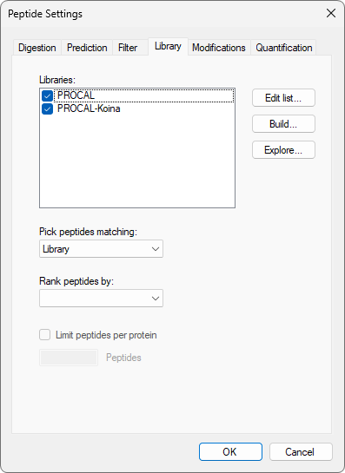
- Click the OK button.
The PROCAL_Koina library is loading in the background.
In the Library Match window Spectrum dropdown list, you can now select one of the two Libraries that are active in the file. Which library spectrum is currently shown is always printed on top of the spectrum together with the peptide sequence and charge state.
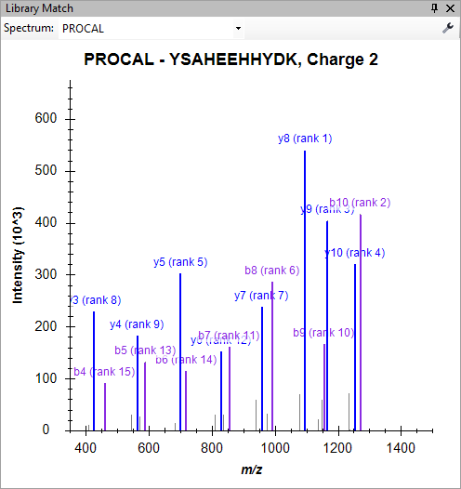 | 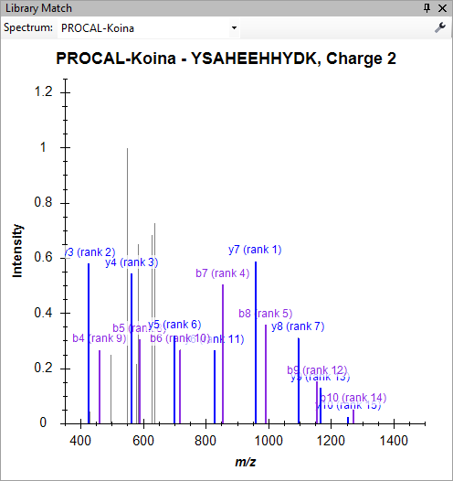
Skyline can only base product-ion selection on a single spectrum from one library. Skyline will search the libraries in the order they appear in the list and use the first spectrum match it finds. With our current settings the PROCAL library is always selected first.
To compare the libraries in a mirror plot:
- Right-click the Library Match graph and click Mirror.
- In the Spectrum list select “PROCAL” and in the Mirror list “PROCAL_Koina”.
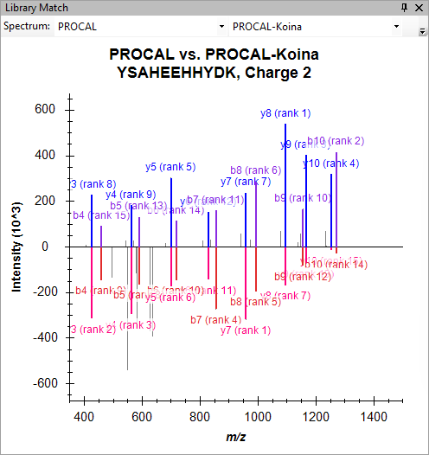
Compare the dotp match factor for different peptides. (TODO: Need properties grid for this)
- Right-click the Library Match graph and click Koina.
Now you get the same mirror plot with a live Koina prediction for CE 31.
- Change the CE setting to “18” and “39”.
Observe how the fragmentation pattern for a peptide changes.
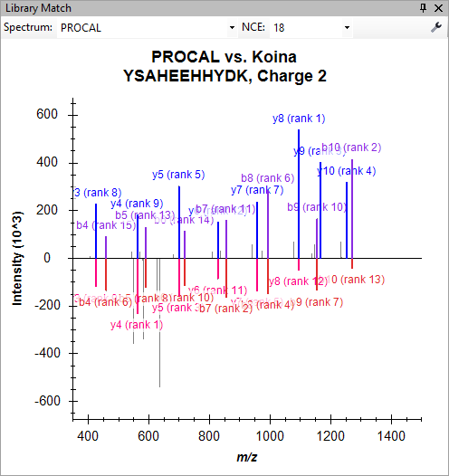 | 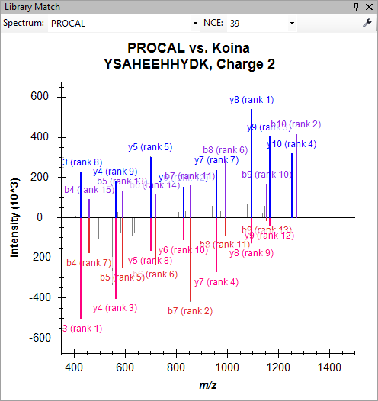
Find for several peptides the optimal CE setting, i.e. the setting where experimental and predicted peptides are as similar as possible. Can the initial setting of “NCE = 31” be further optimized?
- On the File menu, click Save.
- Save the Skyline document as “Tutorial_Libraries” in the tutorial folder.

PRM data analysis
You have created your spectral libraries and selected your target peptide list. In the next step you will extract the chromatogram information for the precursor and transition ions in your list from Thermo mzML files recorded with a PRM method (for settings see Appendix: Background information).
- On the File menu, click Save As.
- Save the document as "Tutorial_PRM".
Before importing data go again to the Settings menu and click Transition Settings
- Select the Full-Scan tab and specify the settings for MS/MS filtering.
- In the Acquisition method field select “PRM”.
- In the Product mass analyzer field select “Centroided”.
- In the Mass Accuracy field enter “10” ppm.
- IMPORTANT: select the option “Include all matching scans”. You need to change this from the standard setting if the retention times recorded in the library do not match the retention times in the file you are importing. Consider this whenever you are combining libraries and files from different LCs, different method settings, different columns etc.
The Transition Settings - Full-Scan tab should look like this:
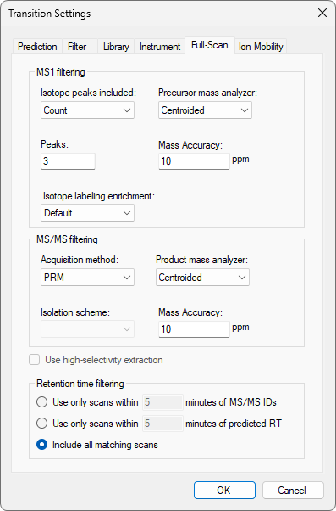
- Click the OK button.
mzML data:
All measurements in this tutorial were recorded as Thermo .raw files. To decrease file size .raw files were converted to .mzML files using MSConvert.
Kessner et al., 2008. ProteoWizard: Open Source Software for Rapid Proteomics Tools Development. Bioinformatics; doi: 10.1093/bioinformatics/btn323).
Martens et al., 2011. mzML – a community standard for mass spectrometry data. MCP; https://doi.org/10.1074/mcp.R110.000133
To import the mzML data:
- On the File menu, choose Import and click Results (Ctrl-R).
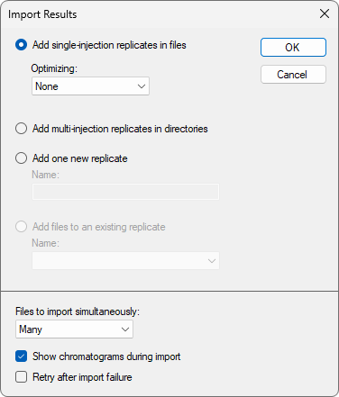
- Click the OK button.
- In the Import Results Files form, navigate to the “1_PRM” subfolder and select the four mzML files.
- Click the Open button.
- Choose not to remove the common “PRM_” prefix.
- Click the OK button.
The Chromatogram information is extracted from the mzML files. With four or more cores, all files will be processed in parallel. On most laptops with two cores, the import will process two files at a time.
Once the import is finished, you want to adjust the Skyline window view. You can drag and dock any window in Skyline by left clicking on the window's top border, holding the left mouse button down, and dragging this window to a new position. Hover over one of the arrow symbols and release the window.
- Drag and drop the Library Match window below the Targets window.
- On the View menu, choose Arrange Graphs and click Tiled.
- On the View menu, choose Retention Times and click Replicate Comparison (F8).
- On the View menu, choose Peak Areas and click Replicate Comparison (F7).
If the Replicate Comparison windows are floating on your Skyline document, drag and dock the Peak Areas - Replicate Comparison and Retention Times - Replicate comparison to a position on the right side of the chromatogram windows so that all information is easily visible.
- On the View menu, choose Auto-Zoom and click Best Peak (F11).
- On the View menu, choose Transitions and click Split Graph.
- On the View menu, choose Transform and click None.
On a small screen the legends take up too much space.
- Right-click a Chromatogram graph and click Legend.
- Do the same for the Replicate Comparison windows.
- Right-click a Chromatogram window and select Synchronize Zooming.
The main Skyline window should now look like this:
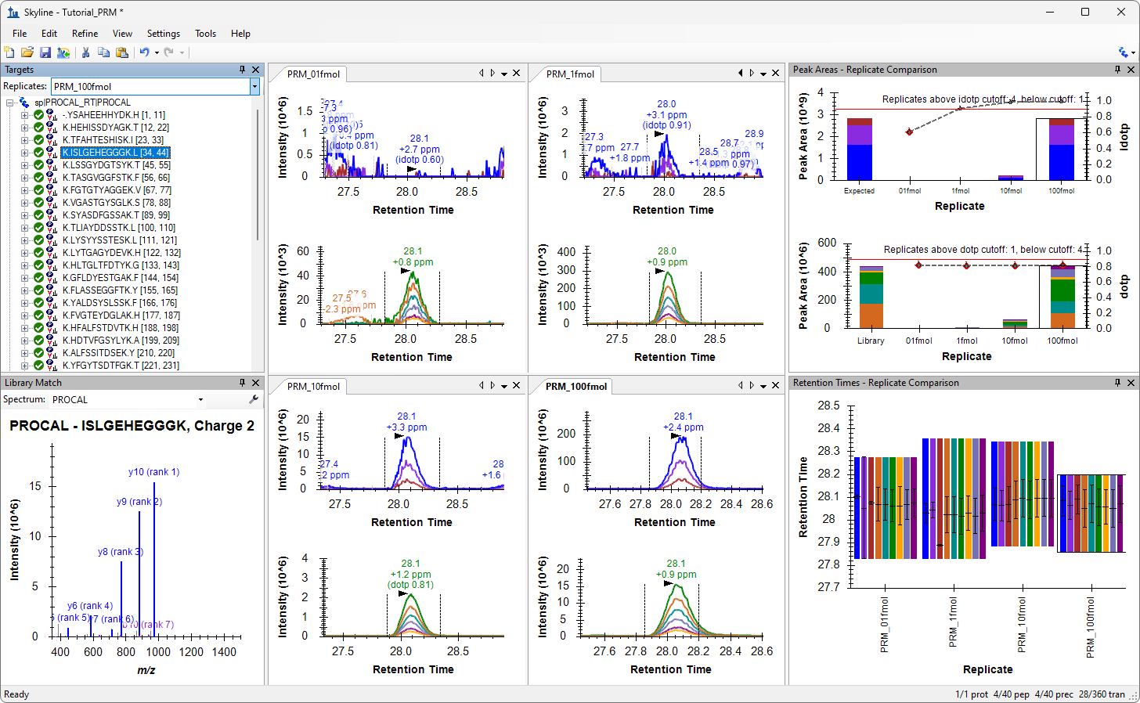
Investigate the different peptide chromatograms as follows:
- Compare the MS1 and MS2 chromatograms for the four PROCAL dilutions.
- Which peptides are not well detected at which concentration?
- Can you find three peptides for which at low concentrations the MS1 signal (precursor ion) has already vanished in the noise, while MS2 signal (product ions) still provide decent chromatogram quality?
- Can you find a peptide that behaves the other way around, i.e. for which MS2 signal is of lower quality than MS1?
- Can you find a peptide with a strong interference in MS1?
Before moving to the next section:
- On the File menu, click Save (Ctrl-S).

DIA Data Analysis
Now that you are already familiar with some Skyline functions, you can easily explore how the PROCAL peptide dilution chromatograms look when measured with DIA (for settings see Appendix: Background information).
For this you need to start a new Skyline document and adjust the settings for DIA.
- Click the New Document button on the toolbar.
- On the File menu, click Start.
- Select the option “Import DIA Peptide Search”.
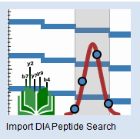
The Import Peptide Search wizard opens. You are presented with the Spectral Library page, which allows you to build a project-specific spectral library. Here you use the database search results and library prediction performed in DIA-NN³ (For settings see Appendix: Background information).
³ Demichev V, Messner CB, Vernardis SI, Lilley KS, Ralser M. DIA-NN: neural networks and interference correction enable deep proteome coverage in high throughput. Nature Methods 17, 41-44 (2020)
- In the Spectral Library window, click Add Files and navigate to the “2_DIA” subfolder.
- Open the “DIA_PROCAL.tsv.speclib” file.
Note: The “DIA_PROCAL.tsv.speclib” file was predicted with DIA-NN based on the PROCAL.fasta (see Appendix: Background information). To read in the spectra information from the measurement files requires in addition the “report.tsv” result file from the DIA-NN database search. Both files, the .speclib and report.tsv file, need to have the same naming. The measurement data files (here mzML) do not need to be located in the same folder.
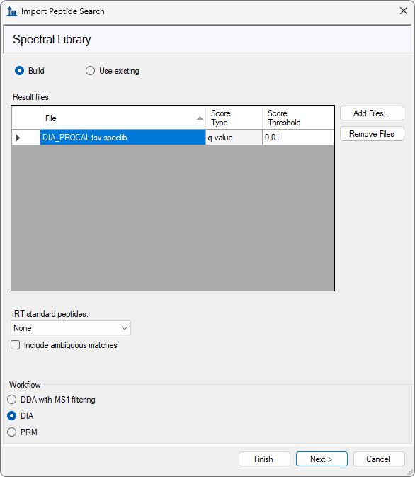
- Click the Next button.

You are presented with the Extract Chromatograms form, in which you can navigate Skyline to the path for the DIA data files it will use for chromatogram extraction, peak detection, and peak area calculation.

- Click the Browse button.
- In the Import Results Files form, navigate to the “2_DIA” subfolder and select the four mzML files.
- Click the Open button.
The Import Peptide Search form should look like this:
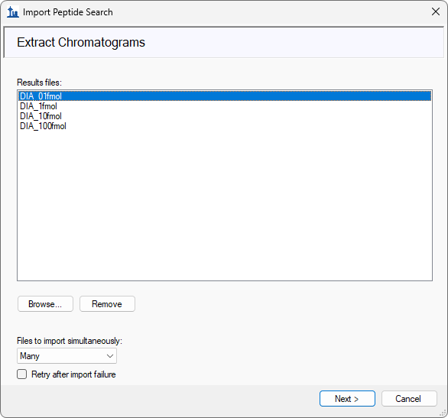
- Click the Next button.
- Choose not to remove the common “DIA_” prefix.
- Click the OK button.
The Import wizard asks if you want to add modifications.
- Click the Next button.
In the Configure Transition Settings page do the following:
- In the Precursor charges field enter “2,3”.
- In the Ion charges field enter “1”
- In the Ion types field enter “y, b, p”.
- In the Product ions fields choose From “ion 2” To “Last ion”.
- In the Min m/z field enter “350”.
- Check the Use DIA precursor isolation window for exclusion checkbox.
- In the Ion match tolerance field use the default “0.05”.
- In the Pick fields enter “6” product ions and “3” min product ions.
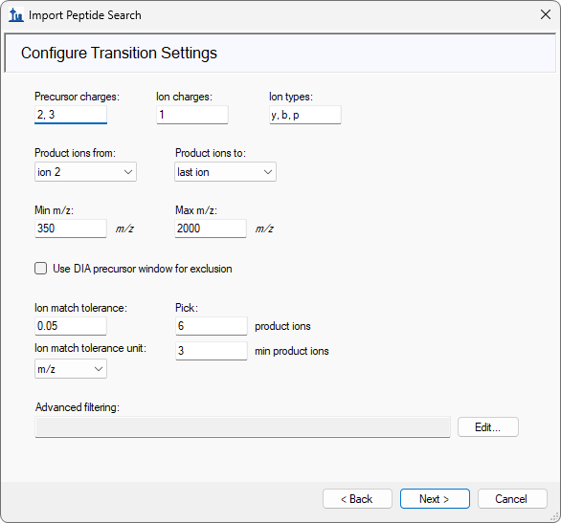
- Click the Next button.
In the Configure Full-Scan Settings page do the following:
- For MS1 filtering, in the Precursor mass analyzer field choose “Centroided”.
- In the Mass Accuracy field enter “10” ppm.
- For MS/MS filtering, in the Isolation scheme field select Add.
- In the Name field enter “DIA_40windows”.
- Choose the option Prespecified isolation windows.
- Click the Import button.
- Navigate to the 2_DIA subfolder and open the first DIA mzML file.
Skyline automatically reads in the DIA windows settings from the mzML file.
- Click the Graph button to have a look at the isolation scheme and then Close.
- Click the OK button in the Edit Isolation Scheme form.
The Configure Full-Scan Settings page should look like this:
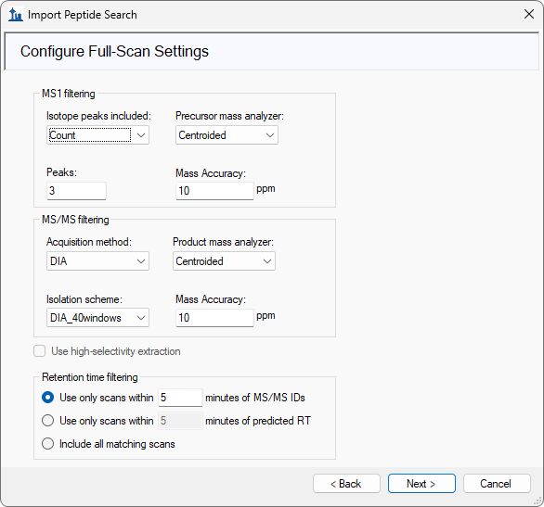
- Click the Next button.
In the Import FASTA page do the following:
- Click the Browse button.
- Navigate to the 1_PRM subfolder.
- Open the “PROCAL.fasta“ file.
- In the Decoy generation method field select “Shuffle Sequence”. (WHY?)
The Import FASTA page should look like this:
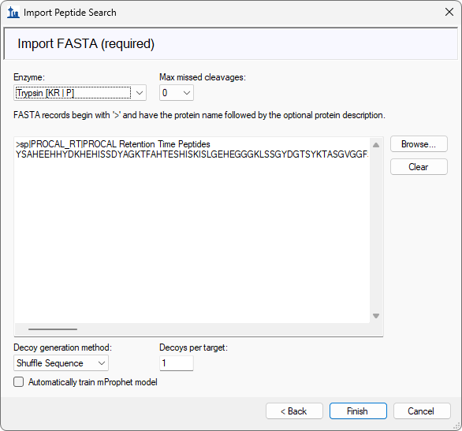
- Click the Finish button.
Skyline shows the Associate Proteins form with the following values for the default options:
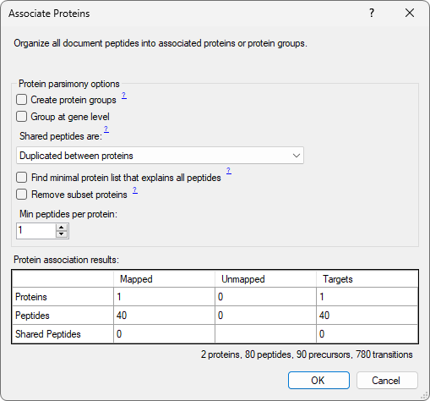
- Click the OK button.
Skyline begins extracting chromatograms from the DIA mzML files. During this time, you can already organize the Skyline windows as before. You should only need to do the following:
- On the View menu, choose Arrange Graphs, and click Tiled.
When the import has completed, Skyline should look like this:
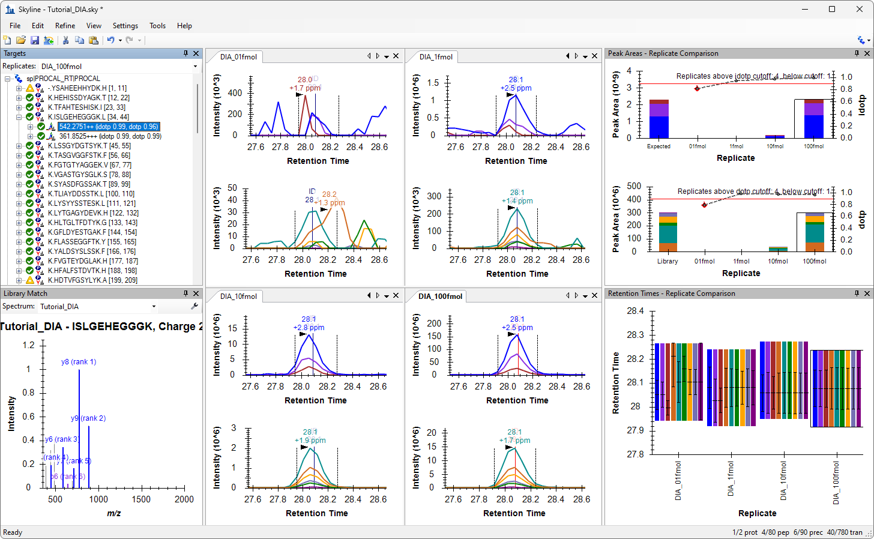
As you have loaded at the beginning of the Import DIA Peptide Search procedure the results file from a DIA-NN analysis (the PROCAL-tsv.speclib and the PROCAL-report.tsv present in the same folder), Skyline is able to show you the retention time at which DIA-NN has successfully identified each peptide in each raw file.
A successful peptide identification is indicated with a dark blue line annoted as “ID”, with the retention time. You can add or remove this peptide identification information by doing the following:
- Right-click any chromatogram graph, choose Peptide ID Times, and click Matching to check or uncheck this item.
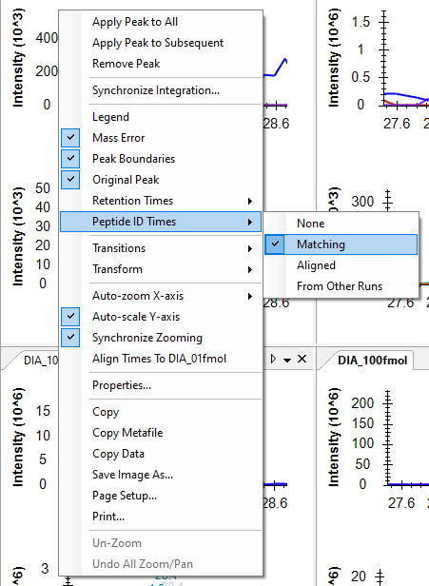
Now quantitatively investigate the different peptide chromatograms.
- Compare the MS1 and MS2 chromatograms for the four PROCAL dilutions.
- Which peptides are not well detected? At which concentrations?
- Look up the peptides you investigated in detail in the PRM data before and compare those in the DIA data.
- Compare the retention time in the 0.1fmol sample for "TASGVGGFSTK". Compare the mass errors for the selected peaks of this peptide over all concentration. Manually correct the peak area integration in the 0.1fmol sample.
- Check the peptide "HDTVFGSYLYK". What is the interfered product ion here? Remove it from the document.
- Manually correct peak area integration and remove interfered product ions for the whole document.
- Have a look at the decoy peptides "GAYDSSIHEHK", "LGSYGTSAGVK" or "TILGDDIVFGK". What is the dotp score for the 0.1fmol sample?
Before moving to the next section:
- On the File menu, click Save (Ctrl-S).

DDA Data Analysis
Now that you are already familiar with some Skyline functions, you can easily explore how the PROCAL peptide dilution chromatograms look when measured with DDA (for settings see Appendix: Background information).
For this you need to start a new Skyline document and adjust the settings for DDA.
- Click the New Document button on the toolbar.
- On the File menu, click Start.
- Select the option “Import DDA Peptide Search”.
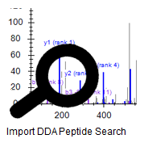
The Import Peptide Search wizard opens. You are presented with the Spectral Library page, which allows you to build a project-specific spectral library. Here you use the database search results from MaxQuant⁴ (For settings see Appendix: Background information)
⁴ Cox J, & Mann M. MaxQuant enables high peptide identification rates, individualized p.p.b.-range mass accuracies and proteome-wide protein quantification. Nature Biotechnology 26, 1367-1372 (2008)
- In the Spectral Library window, click Add Files and navigate to the “3_DDA” subfolder.
- Open the “msms.txt” file.
Note: Reading the spectra information form the measurement files requires msms.txt result file and mqpar.xml file from the MaxQuant search results. The measurement data files (here mzML) must be located in the same folder.
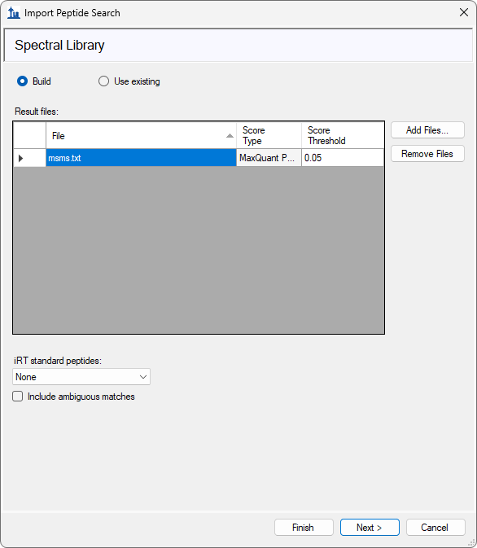
- Click the Next button.
Skyline reads in the identified spectra from the MaxQuant search and creates a new spectral library file.
You are presented with the Extract Chromatograms form where the mzML file(s) used in the search are usually automatically selected if it located in the same folder as the msms.txt folder. If not navigate to the 3_DDA subfolder and select the four DDA mzML files.
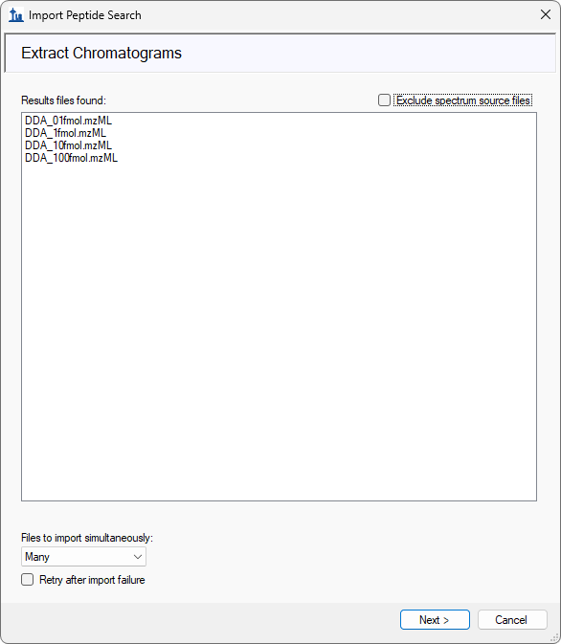
- Click the Next button.
- Choose not to remove the common “DDA_” prefix.
- Click the OK button.
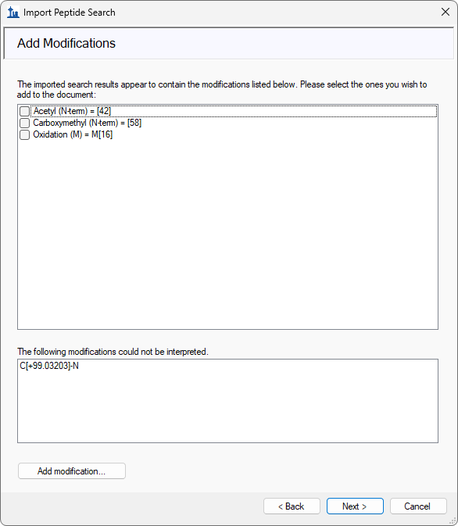
- Click the Next button.
In the Configure Full-Scan Settings page do the following:
- Change the Precursor charges field to “2,3” and otherwise accept defaults.
- In the Precursor mass analyzer field leave “Centroided”.
- In the Mass Accuracy field leave “10” ppm.

The Configure Full-Scan Settings page should look like this:
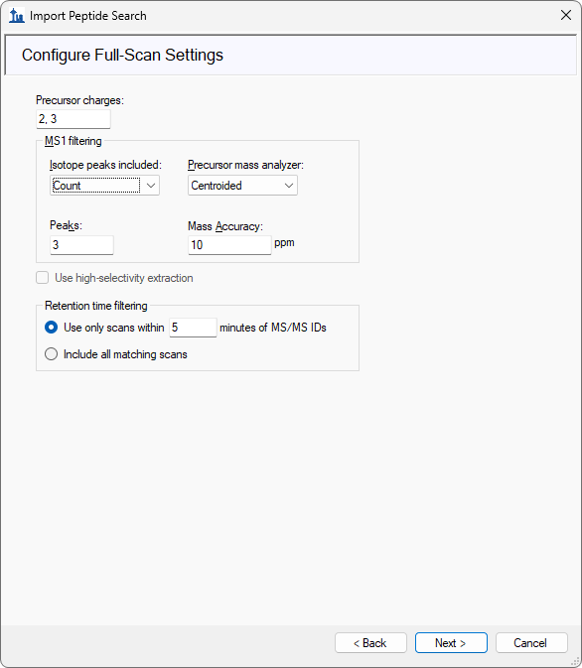
- Click the Next button.
In the Import FASTA page do the following:
- Click the Browse button.
- Navigate to the 1_PRM subfolder.
- Open the “PROCAL.fasta“ file.
The Import FASTA page should look like this:
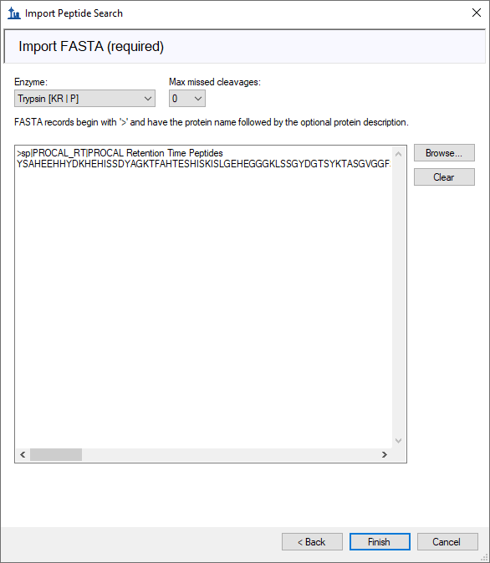
- Click the Finish button.

Skyline shows the Associate Proteins form with the following values for the default options:
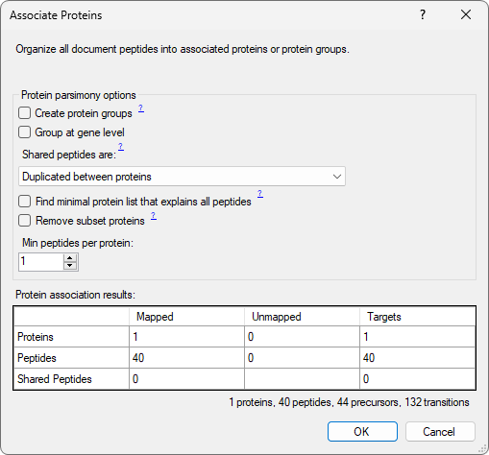
- Click the OK button.
Skyline begins extracting chromatograms from the MS1 spectra in the DDA mzML files. During this time, you can already organize the Skyline windows as before. You should only need to do the following:
- On the View menu, choose Arrange Graphs, and click Tiled.
When the import has completed, Skyline should look like this:
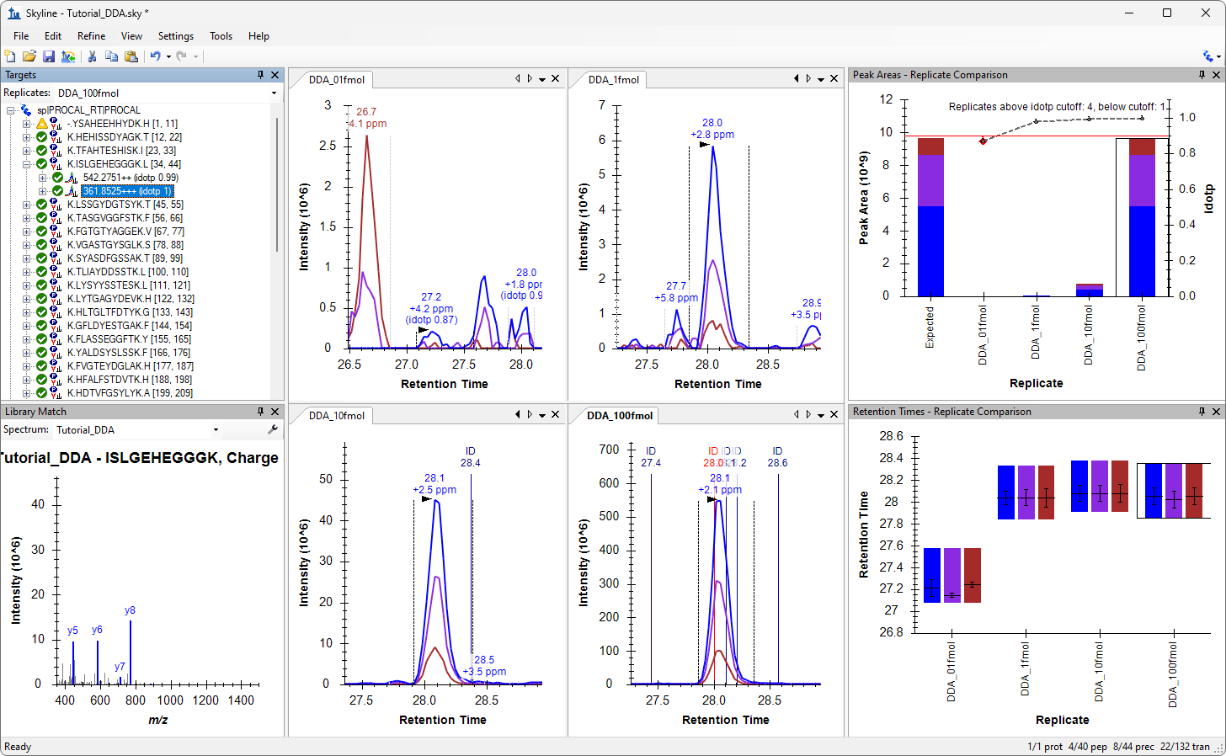
As you have imported DDA data, Skyline will only show you MS1 chromatograms but no product ion (MS2) chromatograms. However, the information if and at which retention time an MS2 spectrum was recorded that led to a successful peptide identification with MaxQuant is indicated with a dark blue line annoted as “ID”, with the retention time. You can add or remove this peptide identification information by doing the following:
- Right-click any chromatogram graph, choose Peptide ID Times and click Matching to check or uncheck this item.
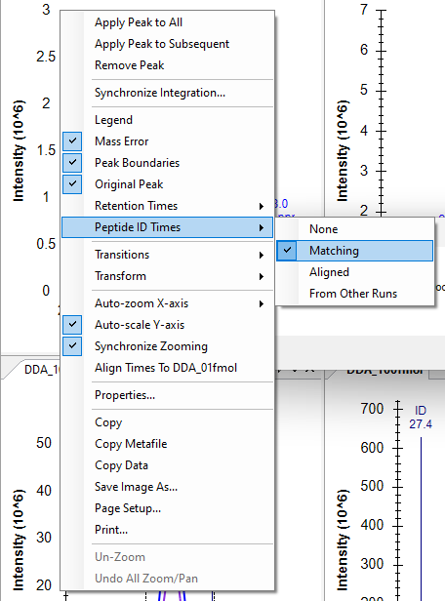
Investigate the identified MS2 spectra for all peptides in your Skyline document.
- How many identified spectra do you tend to get per precursor in each raw file?
- At which concentrations do you tend to get more identifications?
- Do you tend to get MS2 identifications rather in the beginning, the end, or in the middle of the peak/chromatogram?
Now quantitatively investigate the different peptide MS1 chromatograms.
- Compare the MS1 chromatogram peak areas for the four PROCAL dilutions for all peptides.
- Which peptides are not well detected? At which concentration(s)?
- Specifically, look up the peptides “TASGVGGFSTK” and “HLTGLTFDTYK”. Carefully check retention time, idotp and mass errors and how those values change between the different concentrations. What is the issue with the 0.1 fmol sample?
- Manually correct the wrongly integrated peptides in the document.
Before moving to the next section:
- On the File menu, click Save (Ctrl-S).

Conclusion
You have completed this Skyline tutorial! You have learned to import and build spectral libraries and how to investigate target peptides in PRM, DIA or DDA measurement files. The doors are open to go crazy and explore your data in more detail with the many interactive visualizations offered by Skyline.

Extra task for quick people
- Export precursor and product ion total areas from the Skyline document using File Export Report.
- Visualize those ion intensities using your favourite data visualization tool. Think about optimal ways how to plot the data. For example, plot intensity ratios per peptide (measured peptide intensity at each concentration divided by the peptide intensity at 100 fmol) versus peptide retention time for all three data acquisition methods on MS1 and/or MS2 level.
- What general trends do you observe?
- Do you see something that does not fit your expectations?

Background information
- Spectral Libraries

In this tutorial we created spectral libraries for the PROCAL peptide selection. You can do the same for any peptide selection for example using public available spectral library sources like:
- Peptide Atlas (http://www.peptideatlas.org/speclib/)
- National Institute of Standards and Technology (NIST) (https://peptide.nist.gov/)
- The Global Proteome Machine (GPM) (ftp://ftp.thegpm.org/projects/xhunter/libs/)

The Proteome Tools project offers spectral libraries recorded from synthesized peptides at different collision energies and fragmentation settings.
- Proteome Tools (https://www.proteometools.org/index.php?id=53)

You can also create new spectral libraries in Skyline using other publicly available data, or peptide search results from your laboratory experiments. Skyline supports building libraries from the following search result formats:

BlibBuild (https://skyline.ms/wiki/home/software/BiblioSpec/page.view?name=BlibBuild)

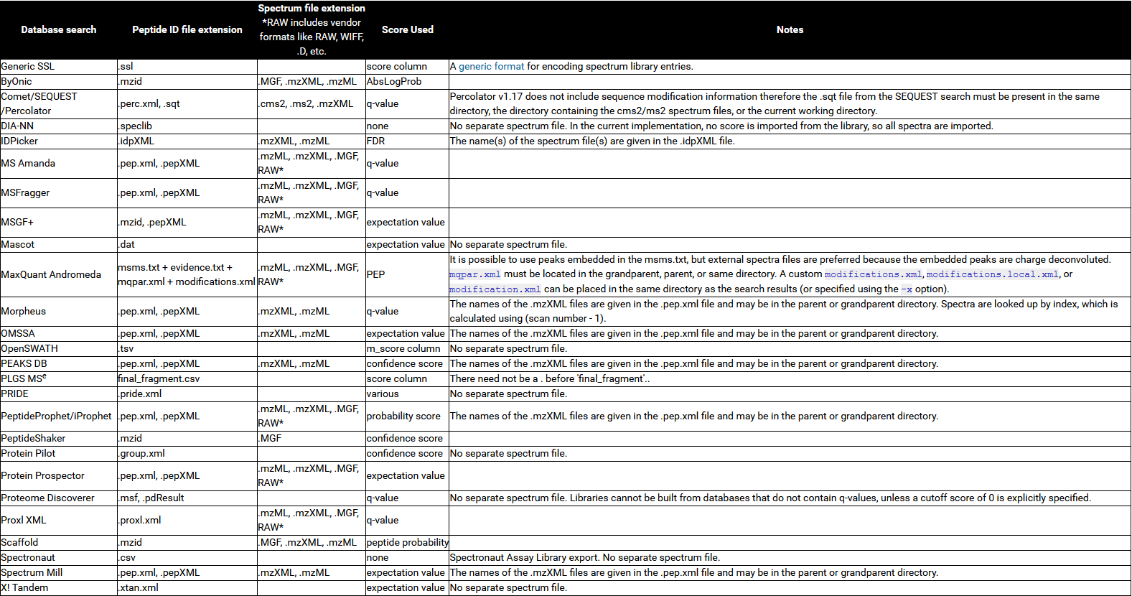

- Custom (SSL) (https://skyline.ms/blib-formats.url)

- Eclipse instrument settings

LC-Settings for PRM, DIA & DDA
Ultimate 3000 RSLCnano system
- Trap column (ReproSil-pur C18-AQ, 5 μm, Dr. Maisch, 20 mm × 75 μm, self-packed) at a flow rate of 5 μL/min in HPLC grade water with 0.1% (v/v) formic acid
- Analytical column (ReproSil Gold C18-AQ, 3 μm, Dr. Maisch, 450 mm × 75 μm, self-packed)
- 50 min linear gradient from 4% to 32% of solvent B (0.1% formic acid and 5% (v/v) DMSO in acetonitrile) at 300 nL/min flow rate. nanoLC solvent A was 0.1% (v/v) formic acid, 5% (v/v) DMSO in HPLC grade water

Orbitrap Eclipse
Parameter | PRM | DIA | DDA
MS1
Orbitrap Resolution | 60,000 | 120,000 | 60,000
Scan Range (m/z) | 360-1300 | 360-1300 | 360-1300
Max IT (ms) | 50 | 50 | 50
Norm.AGC Target | 100% | 100% | 100%
MS2
Isolation Window | 1.3 | - | 1.3
NCE (%) | 30 | 30 | 30
Orbitrap Resolution | 30,000 | 30,000 | 15,000
Scan Range (m/z) | 140-2000 | 200-1800 | -
Max IT (ms) | 120 | 54 | 22
Norm.AGC Target | 400% | 1000% | 200%
Cycle time | - | - | 2
Dynamic exclusion | - | - | 30s
Windows | - | 40 variable

- MaxQuant & DIA-NN settings

MaxQant v.2.4.0.0
Parameter | Settings
Type | Standard
Enzyme | Trypsin/P
Missed clevages | 1
Modifications | Fixed: Carbamidomethyl (C)  Variable: Oxidation (M);Acetyl (Protein N-term)
Label-free quantification | None
Sequences | PROCAL.fasta; human reference UP000005640 Swiss Prot fasta
Match between runs | FALSE
PSM FDR | 1%
Protein FDR | 1%
Min peptide length | 7

DIA-NN v.1.8.1
Parameter | Settings
Spectral library prediction | PROCAL.fasta; human reference UP000005640 Swiss Prot fasta ; contaminants.fastaTrypsin/P; 1 Missed cleavages  0 Maximum number of variable modifications
DIA search
Spectral library | PROCAL predicted library (.speclib)
Peptide length range | 7-30
Precursor m/z range | 360-1300
Fragment ion m/z range | 200-1800
MBR | TRUE
Protein inference | Genes
Neural network classifier | Single-pass mode
Quantification strategy | Robust LC (high precision)
Cross-run normalization | RT-dependent
Library generation | Smart profiling
Speed and RAM usage | Optimal results

- File conversion

Thermo .raw files were converted to mzML files using MSConvert (ProteoWizard: Open Source Software for Rapid Proteomics Tools Development. Darren Kessner; Matt Chambers; Robert Burke; David Agus; Parag Mallick. Bioinformatics 2008; doi: 10.1093/bioinformatics/btn323).

Parameter | Settings
Output format | mzML
Binary encoding precision | 64-bit
Write Index;Use zlib compression;TPP compatibility | TRUE;TRUE;TRUE
Filters | Peak Picking; MS Levels 1-2

Zolg DP, Wilhelm M, Yu P, Knaute T, Zerweck J, Wenschuh H, Reimer U, Schnatbaum K, Kuster B. PROCAL: A set of 40 peptide standards for retention time indexing, column performance monitoring, and collision energy calibration. Proteomics. 2017 Nov; 17(21)

